Input and output devices for disabled people

There are many devices for disabled people to use to work around their disability. For example, Steven Hawking has a “Speech generating device” (SGD). A speech generating device (SGD), also referred to as voice-output communication aids (VOCA), are electronic devices that allow the user to select messages to be spoken aloud, thereby assisting people who are unable to use natural speech to meet the majority of their communication needs. SGD technology ranges from simple to complex. Dedicated devices are intended for communication purposes only, while others are integrated into portable computer systems. Additional components may include but are not limited to environmental controls, switch access, rate enhancement programs, and appointment schedules and reminders.

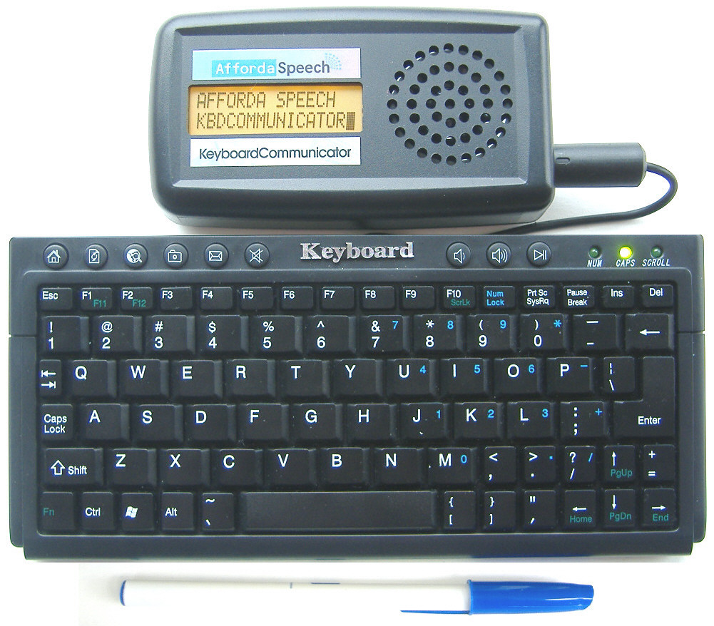

The user must type in what they want to say (input) and then the machine will output what the user has typed via a digitized voice. This is used for people that may be paralysed or have vocal infection, in other words, people that cannot speak naturally with ease.

(EPW)The electric powered wheelchair:

The electric powered wheelchair is a wheel chair that is powered by an electric motor rather than the user propelling his or herself by pulling on the wheels. The user would navigate around with a joystick and the motor will steer and move in the way the user tells it to.

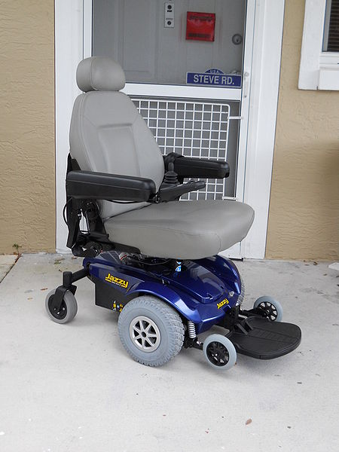

It helps the user by allowing people with cardiovascular disease or people that are paralysed to move around.

Hearing Aid:

A hearing aid is a device that amplifies the sound incoming into the ear’s cochlear. The sound is received by a microphone and emitted by a speaker. It is designed to enable people that are deaf (have a passive ear drum) and people that are partially deaf to hear sounds.

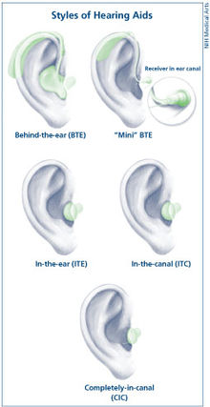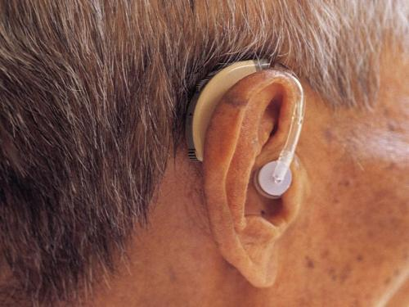

Footmouse:

A foot mouse allows people with amputated arms to use a computer. There are two parts to a foot mouse; the cursor where a user is able to move the on screen cursor to a desired location and a second segment used for selecting on screen buttons or selecting shortcuts.

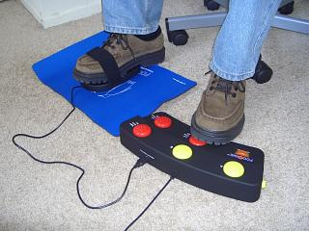

Eye typer:

An eye typer is a device that paralysed people can use to operate a computer. The user’s eyes are tracked by a camera and the user is able to operate the computer by various eye movements, for example, in order to click the user would have to blink slowly.

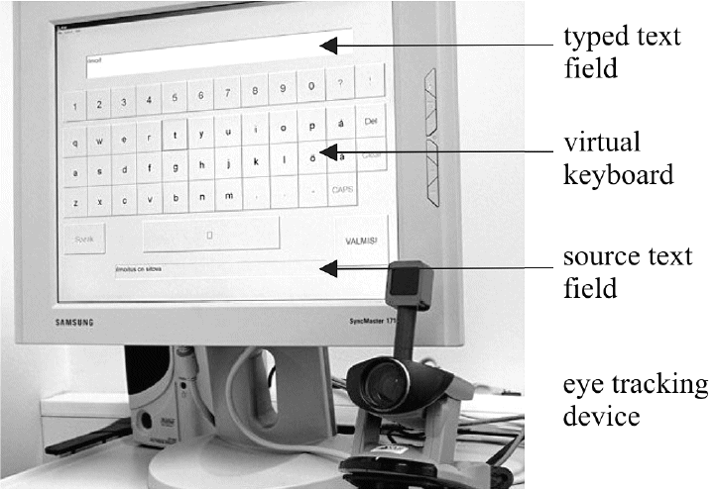

Predictive Text:

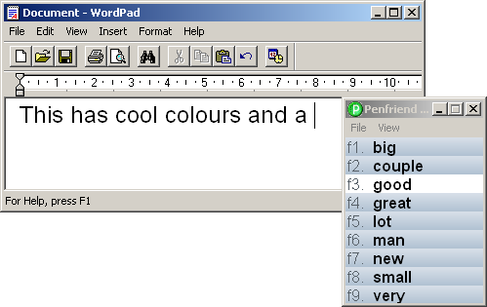This is a common technology that is now available for everyone, commonly known as autocorrect. However, it was initially used for people that had physical difficulties. The user would type a single letter and the computer will predict what the user will write.